Language-like efficiency in whale communication

Mason Youngblood [1]

Human language and other animal communication systems tend to be optimized for efficiency—the benefits that they bestow relative to the costs of learning and producing them. One of the clearest manifestations of communicative efficiency is Menzerath’s law, which predicts that longer sequences (e.g., songs) will be comprised of shorter elements (e.g., notes). In this study, I assessed the evidence for Menzerath’s law in cetaceans by analyzing vocal sequences from 16 baleen and toothed whale species and comparing them to spoken data from 51 human languages. The vocalizations of 11 of the 16 whale species included in this analysis adhere to Menzerath’s law to an extent that is comparable to, and sometimes far greater than, what is observed in spoken human language data. Humpback whales exhibit Menzerath’s law both at the level of notes within phrases and phrases within songs. There is also a broad tendency for vocal shortening—elements or intervals getting shorter over the course of sequences—which may point to simple energetic constraints. Overall, the results of this study suggest that the vocalizations of a wide range of whale species have undergone compression for increased communicative efficiency.

# 1 Introduction

Human language and other forms of animal communication exhibit striking parallels in their structure, such as hierarchical organization (24) and adherence to linguistic laws (25) in some songbirds. These features are thought to reflect common constraints that shape communication systems. Complexity, for example, is thought to boost the informativeness of signals by allowing them to take more forms (26), but more complex signals are generally harder to learn and produce (27). Communication systems tend to balance this trade-off by maximizing their efficiency—the ratio of the lifetime benefits that they provide to the costs of learning and producing them (28).

One of the clearest manifestations of communicative efficiency is Menzerath’s law, which predicts that longer sequences (e.g., songs, words) will be comprised of shorter elements (e.g., notes, phonemes) (29). In other words, when production costs are increased in one domain (e.g., sequence length) they should be decreased in another (e.g., element duration). This negative correlation between sequence length and item length is found at various levels of analysis in language (e.g., phonemes in words, clauses in sentences) (30–33) as well as in music (34). Mathematical modeling work demonstrates that Menzerath’s law is a result of information compression (35–37).

In non-human communication, Menzerath’s law appears to be present in chimpanzee gesture (38) and in the vocalizations of some primates and birds (25,39–43). In cetaceans, though, communicative efficiency is relatively understudied. To my knowledge, Menzerath’s law has only been assessed in the whistle sequences of bottlenose dolphins, where it is present, (44) and in the songs of pygmy blue whales, where it is absent (45). The aim of this study was to assess the evidence for Menzerath’s law in cetaceans by analyzing vocal sequences from 16 baleen and toothed whale species and comparing them to spoken data from 51 human languages.

I focus on Menzerath’s law, rather than other commonly-studied features like Zipf’s laws (46), because its predictions are agnostic about the categories of elements in sequences, thus expanding the number of species that it can be explored in. There are two reasons for this: (1) some species lack detailed classification schemes for their vocal behavior simply because they are understudied, and (2) some species produce rhythmic sequences comprised of one type of click or broadband sound. In these species (e.g., sperm whales, fin whales) the individual element durations are relatively uniform and information is thought to be encoded in the inter-element intervals (3,14,21). As such, I adopt Menzerath’s broader view of his law—“the greater the whole the smaller its parts” (29,47)—and fit it to the durations of either elements or intervals depending on which data are reported (see Figure 1). The logic remains the same in both cases: when longer sequences are comprised of smaller elements or intervals then the total vocalization time is reduced. A study of gelada baboon vocalizations assessed Menzerath’s law using both elements and intervals and found that its strength was similar in both cases (35). In this study, the distributions of element durations and inter-element intervals in the whale vocal sequences have roughly the same shape ([Supplementary Information](https://masonyoungblood.github.io/whale_efficiency/supplement/supplement.html)), and Menzerath’s law is only slightly weaker when computed from intervals (Table 2).

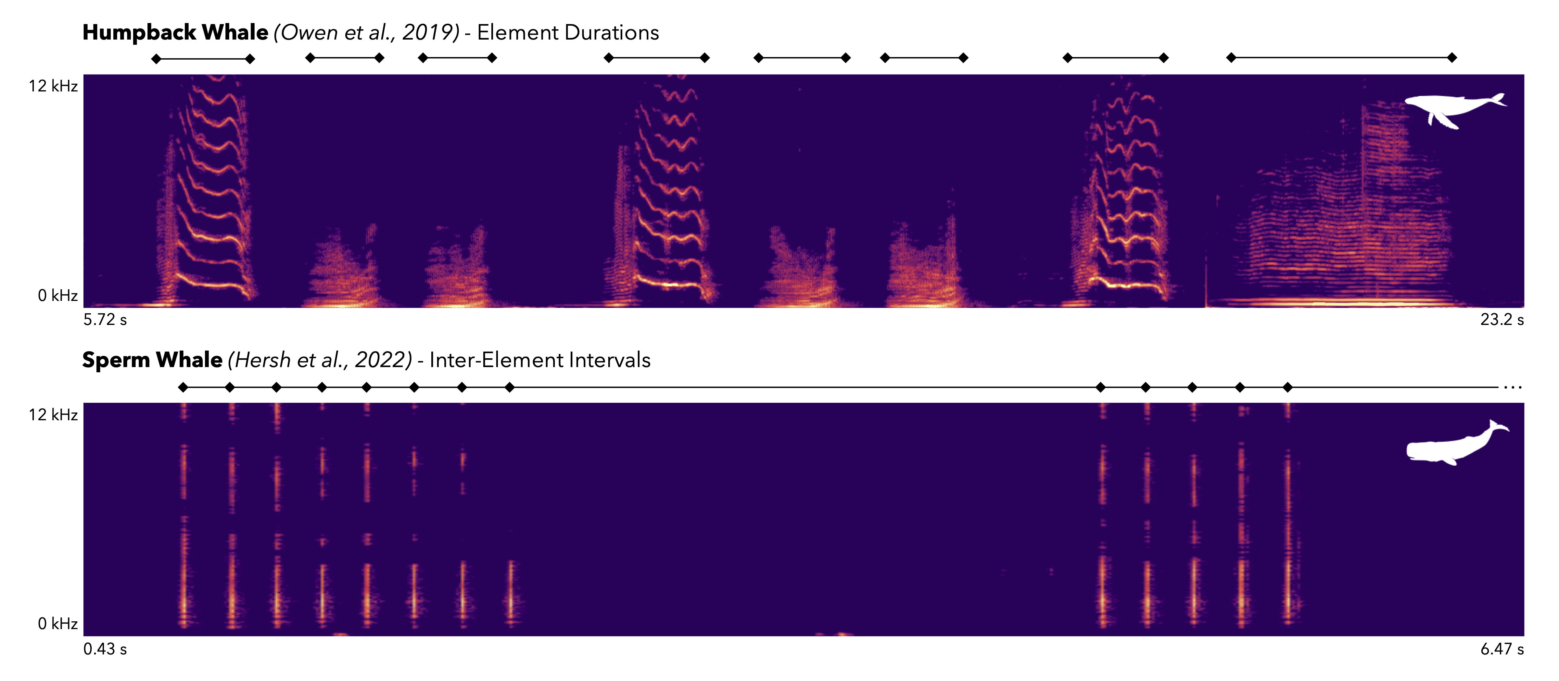

Figure 1: Spectrograms of portions of a humpback whale song (top) and sperm whale coda (bottom) included in this study. The units of interest—element durations for the humpback whale, and inter-element intervals for the sperm whale—are marked by the black lines above each spectrogram. The element durations span from the beginning to the end of a sound, whereas the inter-element intervals span from the beginning of a sound to the beginning of the next sound.

# 2 Methods

## 2.1 Data

Cetacean vocal sequences have different names in different species (e.g., songs, codas, burst-pulses), and there is significant variation in research effort across taxa, so I used a mixture of different strategies to compile a convenience sample of candidate datasets. For heavily studied species I was able to find papers by using species-specific search term combinations like {“humpback whale” AND “song sequences”} and {“sperm whale” AND “codas”} on Google Scholar. For less represented taxa, like dolphins and porpoises, I also searched for datasets directly on repositories like Dryad, Zenodo, and Figshare. Within odontocetes (i.e., toothed whales), who produce clicks for echolocation, I only included vocalizations that have a known or hypothesized communication function (e.g., sperm whale codas, dolphin burst-pulses) (14,21).

In total, I found 43 studies that reported the durations of elements, or the intervals between elements, within vocal sequences. 13 of these had open data that were suitable for analysis. I emailed the corresponding authors of the remaining studies and was granted access to 10 closed datasets that were suitable for analysis. The final 23 datasets can be seen in Table 1 (1–23). Three of the datasets, two in humpback whales (6,7) and one in killer whales (16), were analyzed separately because they log the durations of higher-level units (e.g., for the humpbacks, phrases within songs rather than notes within phrases). Element durations were defined as the time between the beginning and end of a sound (Figure 1). Inter-element intervals were usually defined as the time between the beginning of a sound and the one that comes next, although several studies did not explicitly specify this in their methods (21).

The phrase-level humpback whale dataset (8) was the only one that did not include the durations of individual elements or intervals in sequences. Instead, Owen et al. (8) report the sequences as strings of element categories, with a separate file that logs the durations of many different elements from each category. For this dataset, I interpolated the sequences with the median duration of each element category. Supplementary analysis with human language data suggests that interpolation with median durations systematically reduces the strength of Menzerath’s law, which should lead to more conservative conclusions (see [Supplementary Information](https://masonyoungblood.github.io/whale_efficiency/supplement/supplement.html)).

Table 1: The datasets included in this analysis, with whether they are open access, the vocalization category, and whether the sequences are comprised of element durations or inter-element intervals.

| **Group** | **Species** | **Source** | **Open** | **Vocalization** | **Type** |
| --- | --- | --- | --- | --- | --- |
| Baleen Whale | Blue Whale | Lewis et al. (2018) (1) | Yes | Songs | Durations |
| Bowhead Whale | Erbs et al. (2021) (2) | No | Songs | Durations |
| Fin Whale | Romagosa et al. (2024) (3) | Yes | Songs | Intervals |
| Wood & Sirovic (2022) (4) | Yes | Songs | Intervals |
| Best et al. (2022) (5) | Yes | Songs | Intervals |
| Humpback Whale | Schall et al. (2021) (6) | Yes | Songs | Durations |
| Schall et al. (2022) (7) | Yes | Songs | Durations |
| Owen et al. (2019) (8) | Yes | Phrases | Durations |
| Minke Whale | Martin et al. (2022) (9) | Yes | Call Sequences | Intervals |
| Right Whale | Crance et al. (2019) (10) | No | Songs | Durations |
| Sei Whale | Macklin et al. (2024) (11) | No | Call Sequences | Durations |
| Toothed Whale | Bottlenose Dolphin | Stepanov et al. (2023) (12) | No | Burst Pulses | Intervals |
| Commerson’s Dolphin | Martin et al. (2021) (13) | No | Burst Pulses | Intervals |
| Heaviside’s Dolphin | Martin et al. (2018) (14) | No | Burst Pulses | Intervals |
| Hector’s Dolphin | Nielsen et al. (2024) (15) | No | Burst Pulses | Intervals |
| Killer Whale | Selbmann et al. (2023) (16) | Yes | Call Sequences | Durations |
| Sharpe et al. (2017) (17) | No | Calls | Durations |
| Narrow-Ridged Finless Porpoise | Terada et al. (2022) (18) | No | Burst Pulses | Intervals |
| Peale’s Dolphin | Martin et al. (2024) (19) | No | Burst Pulses | Intervals |
| Risso’s Dolphin | Arranz et al. (2016) (20) | Yes | Burst Pulses | Intervals |
| Sperm Whale | Hersh et al. (2022) (21) | Yes | Codas | Intervals |
| Vachon et al. (2022) (22) | Yes | Codas | Intervals |
| Gero et al. (2016) (23) | Yes | Codas | Intervals |

The phylogeny in Figures 2 and 3 comes from a metatree of Cetacea comprised of both molecular and morphological data (48). As the phylogeny was primarily for visualization purposes, I assigned three species that do not appear in the metatree to close relatives in the same genus: the narrow-ridged finless porpoise (*Neophocaena asiaeorientalis*) to the Indo-Pacific finless porpoise (*Neophocaena phocaenoides*), the Commerson’s dolphin (*Cephalorhynchus commersonii*) to the Chilean dolphin (*Cephalorhynchus eutropia*), and the Peale’s dolphin (*Lagenorhynchus australis*) to the white-beaked dolphin (*Lagenorhynchus albirostris*).

As a comparison with the whale data, I also analyzed spoken language data from DoReCo (49)—a corpus of ~500,000 annotated words (with phonemes) from 51 languages that focuses on small and endangered languages (49). DoReCo has been used in previous studies of Menzerath’s law (32). The only pre-processing was removing everything marked as an “exceptional speech event” (i.e., singing, disfluencies, silent pauses). For the main analysis, I followed Menzerath (29) in using the durations of phonemes within words, but the results with the durations of words within sentences can be found in the [Supplementary Information](https://masonyoungblood.github.io/whale_efficiency/supplement/supplement.html).

## 2.2 Mathematical Models

In this study, I focus on the Menzerath-Altmann law—a precise and more robust mathematical form of Menzerath’s law (47,50). Here is the standard form of the Menzerath-Altmann law where $y$ is the duration of elements within a sequence comprised of $x$ elements, and $a$, $b$, and $c$ are parameters controlling the shape of the relationship.

$$y=ax^{b}e^{cx} \text{(full model)} \left(1\right)$$

$c$ is usually close to 0 when this model is fit to empirical data (43), leading to a reduced model that is its most common form in contemporary linguistics (30).

$$y=ax^{b} \text{(reduced model)} \left(2\right)$$

With some simple algebra we can convert Equation (1) and Equation (2) into linear models.

$$ln\left(y\right)=ln\left(a\right)+bln\left(x\right)+cx \text{(full model)} \left(3\right)$$

$$ln\left(y\right)=ln\left(a\right)+bln\left(x\right) \text{(reduced model)} \left(4\right)$$

I will use Equation (4) to enable direct comparison with previous studies of the Menzerath-Altmann law in non-human animals (12,35,40,41,43,44,51,52), and because the inclusion of $x$ twice in Equation (3) leads to fairly severe problems with multicollinearity ( $\overset{‾}{VIF}$ = 17.2).

$y$ is usually the mean duration of elements within sequences, but I will use the full distribution of element durations within sequences (25). This leads to similar estimates of $a$ and $b$ in linguistic corpora, helps to avoid spurious “regression to the mean” effects (35,53,54), and better captures uncertainty in the models (25). I also follow other work in excluding single-element sequences (i.e., with a length of one) from the analysis, which have been shown to depart from Menzerath’s law (38,50,55,56).

## 2.3 Model Fitting

All models were fit using the *lme4* (v1.1-35.1) package in *R* (v4.3.1) (57) with the BOBYQA optimizer. To avoid the many problems associated with *p*-values (58,59), I report mean estimates and 95% Wald confidence intervals, and interpret intervals that do not overlap zero as indicating a strong effect. To enable direct comparison of fixed effects across different models, I used maximum likelihood and z-scored the sequence lengths and element or interval durations within species and languages (60). All reported models were manually checked for convergence.

The main model used to test Menzerath’s law was Equation (4) with sequence ID as a varying intercept to account for the repeated measurements of durations within sequences. Some species had multiple datasets, in which case the study ID was included as a second varying intercept. Here is the main model in Wilkinson notation—standard R model syntax.

$$ln\left(\text{duration}\right)∼ln\left(\text{length}\right)+\left(1|\text{sequence}\right) \left(5\right)$$

Additionally, I fit a second model that included the position of each element or interval in the sequence as a fixed effect, following previous studies of Menzerath’s law in non-human animals (35,40,43,44,51,52). Position was normalized between 0 and 1 using the function $\left(n-1\right)/\left(l-1\right)$, where $n$ is the position of the element or interval and $l$ is the length of the sequence (43). The purpose of this model was to assess whether Menzerath’s law is driven by a shortening of elements or intervals over the course of the sequence, or a tendency to begin long sequences with shorter elements or intervals.

$$ln\left(\text{duration}\right)∼ln\left(\text{length}\right)+\text{position}+\left(1|\text{sequence}\right) \left(6\right)$$

Finally, I assessed broader cross-species trends in Menzerath’s law with expanded forms of Equation (5) and (6) applied to all species at once. Interactions between length and position and the following two features were added: (1) the group the species comes from, to determine whether the effect varies between Mysticetes and Odontocetes, and (2) the type of vocalization, to determine whether the effect is stronger for elements or intervals. Group and type were not added as separate fixed effects (outside of the interactions) because the z-scaling of duration within species removes species differences. Sequence and study were included as varying intercepts. The effect of sequence length on element/interval duration does not have significant phylogenetic signal ( $K$ = 0.32; $p$ = 0.46), computed using the method of Ives et al. (61) as implemented in the *phytools* package (2.1.1) in *R* (v4.3.1) (62), so I did not include phylogeny in the modeling.

$$\begin{matrix}ln\left(\text{duration}\right) & ∼ln\left(\text{length}\right) \\ & + ln\left(\text{length}\right):\text{group}+ln\left(\text{length}\right):\text{type} \\ & + \left(1|\text{sequence}\right)+\left(1|\text{study}\right) (7)\end{matrix}$$

$$\begin{matrix}ln\left(\text{duration}\right) & ∼ln\left(\text{length}\right) \\ & + ln\left(\text{length}\right):\text{group}+ln\left(\text{length}\right):\text{type} \\ & + \text{position} \\ & + \text{position}:\text{group}+\text{position}:\text{type} \\ & + \left(1|\text{sequence}\right)+\left(1|\text{study}\right) (8)\end{matrix}$$

I originally planned to compare the patterns in the real data with simulated data from a null model that is thought to account for production constraints (43), as I recently did for house finch song (25), but analyses of language data suggest that it is far too conservative of a null model. More details about this exploratory analysis can be found in the [Supplementary Information](https://masonyoungblood.github.io/whale_efficiency/supplement/supplement.html).

# 3 Results

In total, this analysis includes 610,182 elements and intervals from 65,492 sequences, 23 studies, and 16 species.

The strength of Menzerath’s law in baleen and toothed whale species can be seen in Figures 2 and 3, respectively. In all baleen whale species, except for the North Pacific right whale, there is a negative relationship between sequence length and element or interval duration consistent with Menzerath’s law. The results are more mixed for the toothed whale species, where only five of the nine exhibit Menzerath’s law. All three dolphins in the *Cephalorhynchus* genus, as well as killer whales, display a neutral or positive relationship between sequence element and element or interval duration.

Interestingly, the North Pacific right whales have four distinct clusters of sequences in Figure 2, which directly correspond to the four song types identified by Crance et al. (10). The strong positive relationship between sequence length and element duration appears to be driven by the distribution of these clusters. Menzerath’s law makes no predictions about different categories of sequences, but it is worth noting that when Equation (5) is computed separately on each song type the results vary (GS1-PF estimate: -0.11, 95% CI: [-0.17, -0.05]; GS4-DG estimate: 0.01, 95% CI: [-0.03, 0.04]; GS3-PU estimate: -0.03, 95% CI: [-0.05, 0]; GS2-TP estimate: 0.06, 95% CI: [0.04, 0.08]).

For humpback and killer whales, I also assessed Menzerath’s law using data from a higher level of analysis. In humpback whales, I found that the length of songs negatively predicted the duration of phrases (estimate = -0.25, 95% CI: [0.065, 0.377]), similar to the pattern for notes within phrases. Interestingly, in killer whales I found that the length of call sequences negatively predicted the duration of calls (estimate = -0.043, 95% CI: [-0.082, -0.004]), even though the situation is reversed for elements within calls.

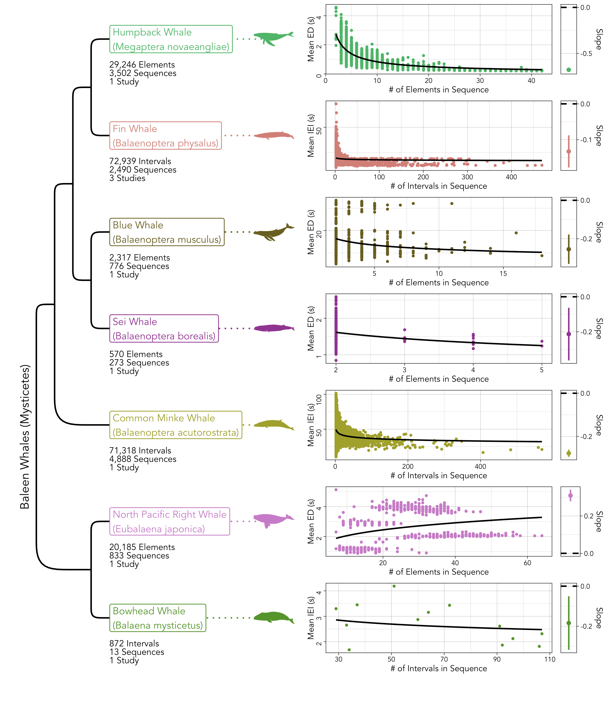

Figure 2: The baleen whale (Mysticete) species included in the study (left), alongside the distribution of element/interval durations and sequence lengths (middle) and the slope of Menzerath’s law (right). Each point in the distribution plots (middle) marks the mean duration of elements/intervals, but the slopes on the right were computed from the full set of elements/intervals. The bars in the slope plots (right) mark the 95% confidence intervals around the point estimates.

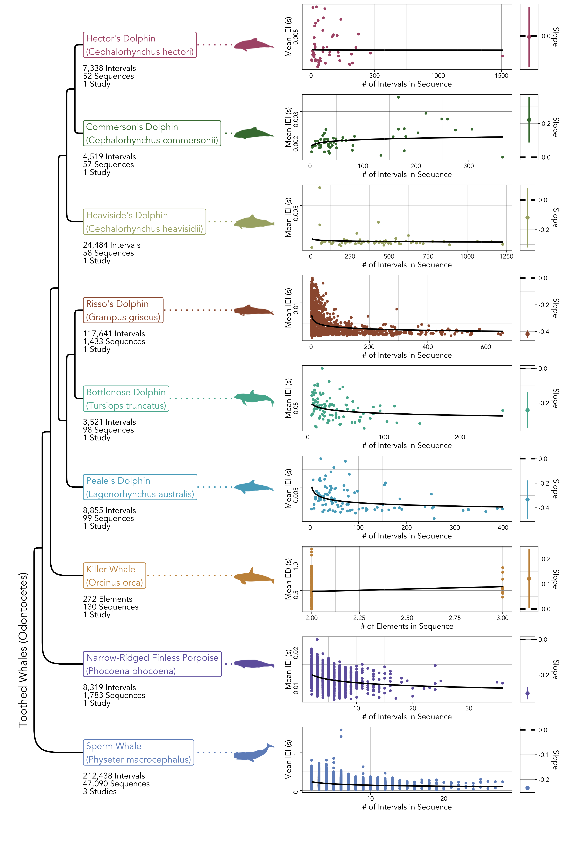

Figure 3: The toothed whale (Odontocete) species included in the study (left), alongside the distribution of element/interval durations and sequence lengths (middle) and the slope of Menzerath’s law (right). Each point in the distribution plots (middle) marks the mean duration of elements/intervals, but the slopes on the right were computed from the full set of elements/intervals. The bars in the slope plots (right) mark the 95% confidence intervals around the point estimates.

Figure 4 shows a direct comparison between the strength of Menzerath’s law in the whale data and the spoken human language data (i.e., phonemes within words) from the DoReCo corpus (49), alongside the influence of the position of elements or intervals on their duration. The same results for words within sentences can be seen in the [Supplementary Information](https://masonyoungblood.github.io/whale_efficiency/supplement/supplement.html). The 11 whale species that adhere to Menzerath’s law express it to at least a similar extent as the human languages, and sometimes to a much greater extent (e.g., humpback whales). The effect of the position of elements and intervals on their duration is much more variable. Human languages tend to have positive relationship between position and duration, which means that elements are lengthened as sequences progress. Whales, on the other hand, appear to shorten elements over the course of sequences (see Table 2), but this varies dramatically across species.

Interestingly, there are several exceptions to Menzerath’s law in the human language data. Arapaho exhibits a positive effect of word length on phoneme duration (Figure 4), and Tabasaran, Sanzhi Dargwa, Pnar, English (recorded in southern England), Yongning Na, and Cabécar show no effect of sentence length on word duration ([Supplementary Information](https://masonyoungblood.github.io/whale_efficiency/supplement/supplement.html)). These exceptions come from a wide variety of language families (e.g., Algic, Nakh-Daghestanian, Austroasiatic, Indo-European, Sino-Tibetan, Chibchan) from North America, Europe, and Asia.

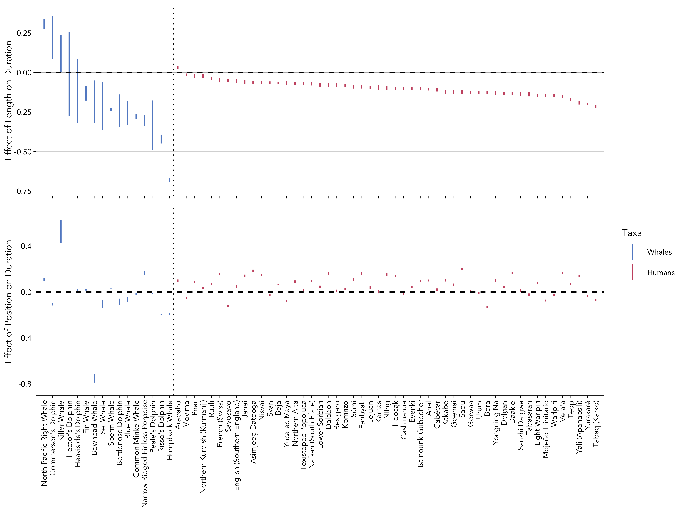

Figure 4: The 95% confidence intervals for the effect of sequence length (top; computed from Equation (5)) and position (bottom; computed from Equation (6)) on element/interval duration for the 16 whale species and 51 human languages. The human language data are comprised of phonemes within words.

Of the two models used to assess cross-species trends, the one that included both length and position best fit the data (Equation (8); $ΔAIC$ = 1846). The results of this model can be seen in Table 2. Overall, there is a strong negative effect of sequence length on the duration of elements and intervals, which is consistent with Menzerath’s law. The interaction between this effect and data type is positive, suggesting that Menzerath’s law is slightly weaker when data are comprised of intervals rather than elements. Additionally, there is a negative effect of position on element duration, indicating that elements tend to shorten as sequences progress. The interactions between position, group, and type suggest two things: toothed whales (Odontocetes) shorten later elements and intervals to a greater extent, and elements tend to get shortened more than intervals over the course of sequences. Importantly, these interactions are strong enough to neutralize the effect of position in some conditions. For example, the overall effect of position on duration in a baleen whale species (Mysticete, group = 0) with interval data (type = 1) would be only -0.005 (95% CI: [-0.018, 0.008]).

Table 2: The estimated effect of each predictor and interaction (indented and marked with :) on the duration of elements in sequences. Length is the sequence length (in number of elements), position is the normalized position of each element in the sequence, group is whether the species is a baleen (0) or toothed (1) whale, and type is whether the data are comprised of elements (0) or intervals (1). 2.5% and 97.5% denote the lower and upper bounds of the 95% confidence intervals. Asterisks mark 95% CIs that do not overlap zero, interpreted here as evidence for a strong effect.

| **Predictor** | **Effect** | **2.5%** | **97.5%** |  |
| --- | --- | --- | --- | --- |
| Length | -0.342 | -0.364 | -0.319 | * |
| : Group | -0.003 | -0.027 | 0.021 |  |
| : Type | 0.089 | 0.058 | 0.121 | * |
| Position | -0.067 | -0.073 | -0.061 | * |
| : Group | -0.036 | -0.040 | -0.032 | * |
| : Type | 0.062 | 0.055 | 0.069 | * |

# 4 Discussion

The vocalizations of 11 of the 16 whale species included in this analysis adhere to Menzerath’s law, suggesting that they have undergone compression for increased communicative efficiency. Among these 11 species, the strength of Menzerath’s law is comparable to, and sometimes far greater than, what is observed in spoken human language data. In the main text, I compared the whale sequences to phonemes within words because I was working with the smallest reported units for each species, but the results are similar for words within sentences (see [Supplementary Information](https://masonyoungblood.github.io/whale_efficiency/supplement/supplement.html)). For two species, humpback whales and killer whales, I was able to analyze sequences at two levels of analysis. Humpback whales exhibit Menzerath’s law for both notes within phrases and phrases within songs. Killer whales, on the other hand, only exhibit Menzerath’s law at the level of call sequences, as opposed to the elements comprising calls. When data from all 16 whale species are included in a single analysis, there is strong evidence for both Menzerath’s law and for an effect of position—elements and intervals tend to be shortened over the course of sequences.

Several species’ produce vocalizations that do not adhere to Menzerath’s law—killer whales (at the level of elements within calls), North Pacific right whales, and the three *Cephalorhynchus* dolphin species. The fact that killer whale vocalizations exhibit Menzerath’s law in their call sequences, but not elements within calls, suggests that the former may be the more relevant level of analysis for communication (63). The results from the North Pacific right whales are more puzzling. The data used in this study are from the first documented recordings of song in any right whale species (10), and are comprised of four song types with fairly dramatic differences in sequence lengths and interval durations (see clusters in Figure 2). When Menzerath’s law is assessed separately on each song type, two display the expected negative relationship, one displays a neutral relationship, and one displays a positive relationship between sequence length and interval duration. One speculative explanation for the mixed results in North Pacific right whales is that the songs may be in an early stage of cultural evolution. Crance et al. (10) found only one clear case of difference animals producing the same song type, and linguistic laws may emerge from repeated cultural transmission between individuals (64). The three *Cephalorhynchus* species in this study—Hector’s dolphins, Commerson’s dolphins, and Heaviside’s dolphins—all produce both narrowband high-frequency and broadband clicks that are thought to function in both echolocation and communication (13–15). I only analyzed the rapid burst pulses of these clicks that are associated with social behavior, but it is possible that the clicks’ use in echolocation reduces pressure for communicative efficiency. However, the burst pulses of the four other dolphin and porpoise species included in this study do adhere to Menzerath’s law, so this hypothesis only makes sense if the boundaries between echolocation and communication are fuzzier in *Cephalorhynchus*. Another interesting detail is that Heaviside’s dolphins produce temporally-patterned burst pulses with much more rhythmic variation in some social situations (65). Data on temporally-patterned burst pulses were not available for use in this study, but it would be interesting to see whether Menzerath’s law is present in these more complex vocalizations.

On a related note, Menzerath’s law does not appear to be universal in spoken language at the level of phonemes in words (Figure 4) or words within sentences ([Supplementary Information](https://masonyoungblood.github.io/whale_efficiency/supplement/supplement.html)), which is consistent with previous work on clauses in written sentences (30,66) and syllables in written words (50,67). Menzerath’s law in language, then, appears to be a statistical tendency rather than an absolute universal (68), as opposed to Zipf’s rank-frequency and brevity laws (69,70).

The shortening of elements and intervals later in sequences is an unexpected finding, as the opposite pattern is often (but not always) observed in birdsong (43,51) and human language (50) (see Figure 4). In fact, “final lengthening” is a well-studied linguistic phenomenon in which vowels are lengthened right before word, phrase, and sentence boundaries (71–73). One account for final lengthening is that it initially evolved to minimize the cost of switching from exhaling to inhaling between elements (74), and has subsequently been elaborated via cultural evolution to make the boundaries between elements easier to perceive (75). Both toothed and baleen whales have specialized adaptations that allow them to vocalize while holding their breath (76,77), which may release them from the specific motor constraints that drive final lengthening (78).

Another explanation comes from primates, where coppery titi monkeys, eastern grey gibbons, and gelada baboons shorten some aspects of their vocalizations over the course of sequences (elements for the first two, intervals for the third) (35,52). Longer vocalizations are more energetically costly (79–81), which is probably why humans and other mammals shorten their vocalizations as they fatigue (82–84). Gustison et al. (35) and Clink and Lau (52) hypothesize that vocal shortening later in sequences reflects this simple energetic constraint, and that it may even explain Menzerath’s law in some species. Other work in humans and birds supports the idea that Menzerath’s law has physical origins (43,55,56)—a development that some have described as “liberating” after decades of debate about the origins of linguistic laws (85). In humans, Menzerath’s law appears to be stronger in spoken than in written language (55,56), and deafened canaries and zebra finches produce songs consistent with the law without hearing adult birds (43). If Gustison et al. (35) and Clink and Lau (52) are correct, then the presence of vocal shortening may point to a physical original for Menzerath’s law in whale communication.

# Acknowledgments

I would like to thank all first authors who contributed data to this study, either directly (via personal correspondence) or indirectly (by publishing open data): Leah Lewis, Florence Erbs, Miriam Romagosa, Megan Wood, Paul Best, Elena Schall, Clare Owen, Cameron Martin, Jessica Crance, Gabrielle Macklin, Arthur Stepanov, Morgan Martin, Nicoline Nielsen, Anna Selbmann, Deborah Sharpe, Tomoyoshi Terada, Patricia Arranz, Taylor Hersh, Felicia Vachon, and Shane Gero.

# Data & Code Availability

The analysis code, and all datasets that were made open access by the original authors, can be found on GitHub (<https://github.com/masonyoungblood/whale_efficiency>) and in the HTML form of the manuscript (<https://masonyoungblood.github.io/whale_efficiency/>). For access to the other datasets that are not publicly available, please reach out to the original authors (see Table 1).

# References

1. Lewis LA, Calambokidis J, Stimpert AK, Fahlbusch J, Friedlaender AS, McKenna MF, et al. Context-dependent variability in blue whale acoustic behaviour. R Soc open sci [Internet]. 2018 Aug [cited 2024 Apr 15];5(8):180241. Available from: <https://royalsocietypublishing.org/doi/10.1098/rsos.180241>

2. Erbs F, Van Der Schaar M, Weissenberger J, Zaugg S, André M. Contribution to unravel variability in bowhead whale songs and better understand its ecological significance. Sci Rep [Internet]. 2021 Jan 8 [cited 2024 Apr 15];11(1):168. Available from: <https://www.nature.com/articles/s41598-020-80220-5>

3. Romagosa M, Nieukirk S, Cascão I, Marques TA, Dziak R, Royer JY, et al. Fin whale song evolution in the North Atlantic. eLife [Internet]. 2024 Jan 9 [cited 2024 Apr 15];13:e83750. Available from: <https://elifesciences.org/articles/83750>

4. Wood M, Širović A. Characterization of fin whale song off the Western Antarctic Peninsula. Li S, editor. PLoS ONE [Internet]. 2022 Mar 10 [cited 2024 Apr 15];17(3):e0264214. Available from: <https://dx.plos.org/10.1371/journal.pone.0264214>

5. Best P, Marxer R, Paris S, Glotin H. Temporal evolution of the Mediterranean fin whale song. Sci Rep [Internet]. 2022 Aug 9 [cited 2024 Apr 15];12(1):13565. Available from: <https://www.nature.com/articles/s41598-022-15379-0>

6. Schall E, Thomisch K, Boebel O, Gerlach G, Mangia Woods S, T. Roca I, et al. Humpback whale song recordings suggest common feeding ground occupation by multiple populations. Sci Rep [Internet]. 2021 Sep 22 [cited 2024 Apr 15];11(1):18806. Available from: <https://www.nature.com/articles/s41598-021-98295-z>

7. Schall E, Djokic D, Ross-Marsh EC, Oña J, Denkinger J, Ernesto Baumgarten J, et al. Song recordings suggest feeding ground sharing in Southern Hemisphere humpback whales. Sci Rep [Internet]. 2022 Aug 17 [cited 2024 Apr 15];12(1):13924. Available from: <https://www.nature.com/articles/s41598-022-17999-y>

8. Owen C, Rendell L, Constantine R, Noad MJ, Allen J, Andrews O, et al. [Migratory convergence facilitates cultural transmission of humpback whale song](https://doi.org/10.1098/rsos.190337). Royal Society Open Science. 2019;6(9).

9. Martin CR, Guazzo RA, Helble TA, Alongi GC, Durbach IN, Martin SW, et al. North Pacific minke whales call rapidly when calling conspecifics are nearby. Front Mar Sci [Internet]. 2022 Aug 22 [cited 2024 Apr 15];9:897298. Available from: <https://www.frontiersin.org/articles/10.3389/fmars.2022.897298/full>

10. Crance JL, Berchok CL, Wright DL, Brewer AM, Woodrich DF. Song production by the North Pacific right whale, Eubalaena japonica. The Journal of the Acoustical Society of America [Internet]. 2019 Jun 1 [cited 2024 Apr 15];145(6):3467–79. Available from: <https://pubs.aip.org/jasa/article/145/6/3467/940279/Song-production-by-the-North-Pacific-right-whale>

11. Macklin GF, Moors-Murphy HB, Leonard ML. Characteristics and spatiotemporal variation of sei whale (Balaenoptera borealis) downsweeps recorded in Atlantic Canada. The Journal of the Acoustical Society of America [Internet]. 2024 Jan 1 [cited 2024 Apr 15];155(1):145–55. Available from: <https://pubs.aip.org/jasa/article/155/1/145/2932685/Characteristics-and-spatiotemporal-variation-of>

12. Stepanov A, Zhivomirov H, Nedelchev I, Stateva P. Bottlenose dolphins’ broadband clicks are structured for communication [Internet]. Animal Behavior and Cognition; 2023 Jan [cited 2023 Sep 19]. Available from: <http://biorxiv.org/lookup/doi/10.1101/2023.01.11.523588>

13. Martin MJ, Torres Ortiz S, Reyes Reyes MV, Marino A, Iñíguez Bessega M, Wahlberg M. Commerson’s dolphins (Cephalorhynchus commersonii) can relax acoustic crypsis. Behav Ecol Sociobiol [Internet]. 2021 Jun [cited 2024 Apr 9];75(6):100. Available from: <https://link.springer.com/10.1007/s00265-021-03035-y>

14. Martin MJ, Gridley T, Elwen SH, Jensen FH. Heaviside’s dolphins (Cephalorhynchus heavisidii) relax acoustic crypsis to increase communication range. Proc R Soc B [Internet]. 2018 Jul 25 [cited 2024 Apr 9];285(1883):20181178. Available from: <https://royalsocietypublishing.org/doi/10.1098/rspb.2018.1178>

15. Nielsen NA, Dawson SM, Torres Ortiz S, Wahlberg M, Martin MJ. Hector’s dolphins (Cephalorhynchus hectori) produce both narrowband high-frequency and broadband acoustic signals. The Journal of the Acoustical Society of America [Internet]. 2024 Feb 1 [cited 2024 Apr 9];155(2):1437–50. Available from: <https://pubs.aip.org/jasa/article/155/2/1437/3265783/Hector-s-dolphins-Cephalorhynchus-hectori-produce>

16. Selbmann A, Miller PJO, Wensveen PJ, Svavarsson J, Samarra FIP. Call combination patterns in Icelandic killer whales (Orcinus orca). Sci Rep [Internet]. 2023 Dec 8 [cited 2024 Apr 15];13(1):21771. Available from: <https://www.nature.com/articles/s41598-023-48349-1>

17. Sharpe DL, Castellote M, Wade PR, Cornick LA. Call types of Bigg’s killer whales (Orcinus orca) in western Alaska: using vocal dialects to assess population structure. Bioacoustics [Internet]. 2017 [cited 2024 May 1];28(1):74–99. Available from: <https://www.tandfonline.com/doi/full/10.1080/09524622.2017.1396562>

18. Terada T, Morisaka T, Wakabayashi I, Yoshioka M. Communication sounds produced by captive narrow-ridged finless porpoises (Neophocaena asiaeorientalis). J Ethol [Internet]. 2022 Sep [cited 2024 Apr 15];40(3):245–56. Available from: <https://link.springer.com/10.1007/s10164-022-00755-0>

19. Martin MJ, Ortiz ST, Wahlberg M, Weir CR. Peale’s dolphins (Lagenorhynchus australis) are acoustic mergers between dolphins and porpoises. Journal of Experimental Marine Biology and Ecology [Internet]. 2024 Mar [cited 2024 Apr 9];572:151977. Available from: <https://linkinghub.elsevier.com/retrieve/pii/S0022098123001090>

20. Arranz P, DeRuiter SL, Stimpert AK, Neves S, Friedlaender AS, Goldbogen JA, et al. Discrimination of fast click series produced by tagged Risso’s dolphins (Grampus griseus) for echolocation or communication. Journal of Experimental Biology [Internet]. 2016 Jan 1 [cited 2024 Apr 15];jeb.144295. Available from: <https://journals.biologists.com/jeb/article/doi/10.1242/jeb.144295/262485/Discrimination-of-fast-click-series-produced-by>

21. Hersh TA, Gero S, Rendell L, Cantor M, Weilgart L, Amano M, et al. Evidence from sperm whale clans of symbolic marking in non-human cultures. Proc Natl Acad Sci USA [Internet]. 2022 Sep 13 [cited 2024 Apr 15];119(37):e2201692119. Available from: <https://pnas.org/doi/full/10.1073/pnas.2201692119>

22. Vachon F, Hersh TA, Rendell L, Gero S, Whitehead H. Ocean nomads or island specialists? Culturally driven habitat partitioning contrasts in scale between geographically isolated sperm whale populations. R Soc open sci [Internet]. 2022 May [cited 2024 May 21];9(5):211737. Available from: <https://royalsocietypublishing.org/doi/10.1098/rsos.211737>

23. Gero S, Whitehead H, Rendell L. Individual, unit and vocal clan level identity cues in sperm whale codas. R Soc open sci [Internet]. 2016 Jan [cited 2024 Apr 15];3(1):150372. Available from: <https://royalsocietypublishing.org/doi/10.1098/rsos.150372>

24. Sainburg T, Theilman B, Thielk M, Gentner TQ. Parallels in the sequential organization of birdsong and human speech. Nat Commun [Internet]. 2019 Aug 12 [cited 2023 Apr 17];10(1):3636. Available from: <https://www.nature.com/articles/s41467-019-11605-y>

25. Youngblood M. [Language-like efficiency and structure in house finch song](https://doi.org/10.1098/rspb.2024.0250). Proceedings of the Royal Society B. 2024;291(2020):20240250.

26. Fitch WT. The evolution of speech: a comparative review. Trends in Cognitive Sciences [Internet]. 2000 Jul [cited 2023 Aug 30];4(7):258–67. Available from: <https://linkinghub.elsevier.com/retrieve/pii/S1364661300014947>

27. Gibson E, Futrell R, Piantadosi SP, Dautriche I, Mahowald K, Bergen L, et al. How efficiency shapes human language. Trends in Cognitive Sciences [Internet]. 2019 May [cited 2023 Apr 12];23(5):389–407. Available from: <https://linkinghub.elsevier.com/retrieve/pii/S1364661319300580>

28. Gruber T, Chimento M, Aplin LM, Biro D. Efficiency fosters cumulative culture across species. Phil Trans R Soc B [Internet]. 2022 Jan 31 [cited 2023 Apr 12];377(1843):20200308. Available from: <https://royalsocietypublishing.org/doi/10.1098/rstb.2020.0308>

29. Menzerath P. Die Architektonik des Deutschen Wortschatzes. Bonn: Dümmler; 1954.

30. Hou R, Huang CR, Do HS, Liu H. A study on correlation between Chinese sentence and constituting clauses based on the Menzerath-Altmann Law. Journal of Quantitative Linguistics [Internet]. 2017 Oct 2 [cited 2024 Apr 17];24(4):350–66. Available from: <https://www.tandfonline.com/doi/full/10.1080/09296174.2017.1314411>

31. Cramer I. The parameters of the Altmann-Menzerath law. Journal of Quantitative Linguistics [Internet]. 2005 Apr [cited 2023 Aug 9];12(1):41–52. Available from: <http://www.tandfonline.com/doi/abs/10.1080/09296170500055301>

32. Stave M, Paschen L, Pellegrino F, Seifart F. Optimization of morpheme length: a cross-linguistic assessment of Zipf’s and Menzerath’s laws. Linguistics Vanguard [Internet]. 2021 Apr 21 [cited 2023 Aug 9];7(s3):20190076. Available from: <https://www.degruyter.com/document/doi/10.1515/lingvan-2019-0076/html>

33. Eroglu S. Menzerath–Altmann law for distinct word distribution analysis in a large text. Physica A: Statistical Mechanics and its Applications [Internet]. 2013 Jun [cited 2023 Aug 9];392(12):2775–80. Available from: <https://linkinghub.elsevier.com/retrieve/pii/S0378437113001702>

34. Boroda M, Altmann G. Menzerath’s law in musical texts. Musikometrica. 1991;3:1–13.

35. Gustison ML, Semple S, Ferrer-i-Cancho R, Bergman TJ. Gelada vocal sequences follow Menzerath’s linguistic law. Proc Natl Acad Sci USA [Internet]. 2016 May 10 [cited 2024 Mar 7];113(19). Available from: <https://pnas.org/doi/full/10.1073/pnas.1522072113>

36. Ferrer-i-Cancho R. Compression and the origins of Zipf’s law for word frequencies. Complexity [Internet]. 2016 Nov [cited 2023 Aug 28];21(S2):409–11. Available from: <https://onlinelibrary.wiley.com/doi/10.1002/cplx.21820>

37. Ferrer-i-Cancho R, Bentz C, Seguin C. Optimal coding and the origins of Zipfian laws. Journal of Quantitative Linguistics [Internet]. 2022 Apr 3 [cited 2023 Sep 21];29(2):165–94. Available from: <https://www.tandfonline.com/doi/full/10.1080/09296174.2020.1778387>

38. Heesen R, Hobaiter C, Ferrer-i-Cancho R, Semple S. [Linguistic laws in chimpanzee gestural communication](https://doi.org/10.1098/rspb.2018.2900). Proceedings of the Royal Society B: Biological Sciences. 2019;286:20182900.

39. Gustison ML, Semple S, Ferrer-i-Cancho R, Bergman TJ. Gelada vocal sequences follow Menzerath’s linguistic law. Proc Natl Acad Sci USA [Internet]. 2016 May 10 [cited 2023 May 29];113(19). Available from: <https://pnas.org/doi/full/10.1073/pnas.1522072113>

40. Huang M, Ma H, Ma C, Garber PA, Fan P. Male gibbon loud morning calls conform to Zipf’s law of brevity and Menzerath’s law: insights into the origin of human language. Animal Behaviour [Internet]. 2020 Feb [cited 2023 Aug 9];160:145–55. Available from: <https://linkinghub.elsevier.com/retrieve/pii/S000334721930377X>

41. Favaro L, Gamba M, Cresta E, Fumagalli E, Bandoli F, Pilenga C, et al. Do penguins’ vocal sequences conform to linguistic laws? Biol Lett [Internet]. 2020 Feb [cited 2023 Aug 9];16(2):20190589. Available from: <https://royalsocietypublishing.org/doi/10.1098/rsbl.2019.0589>

42. Fedurek P, Zuberbühler K, Semple S. Trade-offs in the production of animal vocal sequences: insights from the structure of wild chimpanzee pant hoots. Front Zool [Internet]. 2017 Dec [cited 2023 Aug 9];14(1):50. Available from: <http://frontiersinzoology.biomedcentral.com/articles/10.1186/s12983-017-0235-8>

43. James LS, Mori C, Wada K, Sakata JT. Phylogeny and mechanisms of shared hierarchical patterns in birdsong. Current Biology [Internet]. 2021 Jul [cited 2023 Apr 12];31(13):2796–2808.e9. Available from: <https://linkinghub.elsevier.com/retrieve/pii/S0960982221005285>

44. Vradi AA. Dolphin communication. A quantitative linguistics approach [Internet]. Universitat Politècnica de Catalunya; 2021. Available from: <http://hdl.handle.net/2117/348201>

45. Jolliffe CD, McCauley RobertD, Gavrilov AN. Variability in temporal characteristics of the south eastern Indian Ocean pygmy blue whale song. AB&C [Internet]. 2023 Aug 1 [cited 2024 Apr 15];10(3):211–31. Available from: <https://www.animalbehaviorandcognition.org/uploads/journals/53/2%20Jolliffe_et_al_ABC_10(3).pdf>

46. Semple S, Ferrer-i-Cancho R, Gustison ML. Linguistic laws in biology. Trends in Ecology & Evolution [Internet]. 2022 Jan [cited 2023 Aug 3];37(1):53–66. Available from: <https://linkinghub.elsevier.com/retrieve/pii/S0169534721002305>

47. Altmann G. Prolegomena to Menzerath’s law. Glottometrika. 1980;2:1–10.

48. Lloyd GT, Slater GJ. A total-group phylogenetic metatree for Cetacea and the importance of fossil data in diversification analyses. López-Fernández H, editor. Systematic Biology [Internet]. 2021 Aug 11 [cited 2024 Apr 17];70(5):922–39. Available from: <https://academic.oup.com/sysbio/article/70/5/922/6122448>

49. Seifart F, Paschen L, Stave M. Language Documentation Reference Corpus (DoReCo) [Internet]. 2022. Available from: <https://doreco.huma-num.fr/>

50. G. Torre I, Dębowski Ł, Hernández-Fernández A. Can Menzerath’s law be a criterion of complexity in communication? Amancio DR, editor. PLoS ONE [Internet]. 2021 Aug 20 [cited 2023 Aug 9];16(8):e0256133. Available from: <https://dx.plos.org/10.1371/journal.pone.0256133>

51. Lewis RN, Kwong A, Soma M, De Kort SR, Gilman RT. Java sparrow song conforms to Menzerath’s Law but not Zipf’s Law of Abbreviation [Internet]. Animal Behavior and Cognition; 2023 Dec [cited 2024 Jan 25]. Available from: <http://biorxiv.org/lookup/doi/10.1101/2023.12.13.571437>

52. Clink DJ, Lau AR. Adherence to Menzerath’s Law is the exception (not the rule) in three duetting primate species. R Soc open sci [Internet]. 2020 Nov [cited 2023 Aug 9];7(11):201557. Available from: <https://royalsocietypublishing.org/doi/10.1098/rsos.201557>

53. Milička J. Menzerath’s law: Is it just regression toward the mean? Glottometrics [Internet]. 2023 [cited 2024 Mar 7];55:1–16. Available from: <https://glottometrics.iqla.org/409-menzeraths-law-is-it-just-regression-toward-the-mean/>

54. Ferrer-i-Cancho R, Hernández-Fernández A, Baixeries J, Dębowski Ł, Mačutek J. When is Menzerath-Altmann law mathematically trivial? a new approach. Statistical Applications in Genetics and Molecular Biology [Internet]. 2014 Jan 1 [cited 2023 Aug 9];13(6). Available from: <https://www.degruyter.com/document/doi/10.1515/sagmb-2013-0034/html>

55. Torre IG, Luque B, Lacasa L, Kello CT, Hernández-Fernández A. On the physical origin of linguistic laws and lognormality in speech. R Soc open sci [Internet]. 2019 Aug [cited 2023 Apr 12];6(8):191023. Available from: <https://royalsocietypublishing.org/doi/10.1098/rsos.191023>

56. Hernández-Fernández A, G. Torre I, Garrido JM, Lacasa L. Linguistic laws in speech: The case of Catalan and Spanish. Entropy [Internet]. 2019 Nov 26 [cited 2024 Mar 11];21(12):1153. Available from: <https://www.mdpi.com/1099-4300/21/12/1153>

57. Bates D, Mächler M, Bolker B, Walker S. [Fitting linear mixed-effects models using lme4](https://doi.org/10.18637/jss.v067.i01). Journal of Statistical Software. 2015;67(1):1–48.

58. Nuzzo R. [Scientific method: statistical errors](https://doi.org/10.1038/506150a). Nature. 2014;506:150–2.

59. Amrhein V, Greenland S, McShane B. [Retire statistical significance](https://doi.org/10.1038/d41586-019-00857-9). Nature. 2019;567:305–7.

60. Fox GA, Negrete-Yankelevich S, Sosa VJ. Ecological Statistics: Contemporary Theory and Application. Oxford University Press; 2015.

61. Ives AR, Midford PE, Garland T. Within-species variation and measurement error in phylogenetic comparative methods. Oakley T, editor. Systematic Biology [Internet]. 2007 Apr 1 [cited 2024 Apr 19];56(2):252–70. Available from: <https://academic.oup.com/sysbio/article/56/2/252/1687174>

62. Revell LJ. phytools 2.0: an updated R ecosystem for phylogenetic comparative methods (and other things). PeerJ [Internet]. 2024 Jan 5 [cited 2024 Apr 19];12:e16505. Available from: <https://peerj.com/articles/16505>

63. Kershenbaum A, Blumstein DT, Roch MA, Akçay Ç, Backus G, Bee MA, et al. Acoustic sequences in non-human animals: a tutorial review and prospectus. Biol Rev [Internet]. 2016 [cited 2023 Jun 1];91:13–52. Available from: <https://doi.org/10.1111/brv.12160>

64. Arnon I, Kirby S. Cultural evolution creates the statistical structure of language. Sci Rep [Internet]. 2024 Mar 4 [cited 2024 May 16];14(1):5255. Available from: <https://www.nature.com/articles/s41598-024-56152-9>

65. Martin MJ, Elwen SH, Kassanjee R, Gridley T. To buzz or burst-pulse? The functional role of Heaviside’s dolphin, Cephalorhynchus heavisidii, rapidly pulsed signals. Animal Behaviour [Internet]. 2019 Apr [cited 2024 Mar 8];150:273–84. Available from: <https://linkinghub.elsevier.com/retrieve/pii/S0003347219300089>

66. Tanaka-Ishii K. Menzerath’s law in the syntax of languages compared with random sentences. Entropy [Internet]. 2021 May 25 [cited 2023 Aug 9];23(6):661. Available from: <https://www.mdpi.com/1099-4300/23/6/661>

67. Meyer P. Laws and theories in quantitative linguistics. Glottometrics. 2002;5:62–80.

68. Piantadosi ST, Gibson E. Quantitative standards for absolute linguistic universals. Cognitive Science [Internet]. 2014 May [cited 2024 May 15];38(4):736–56. Available from: <https://onlinelibrary.wiley.com/doi/10.1111/cogs.12088>

69. Piantadosi ST. Zipf’s word frequency law in natural language: A critical review and future directions. Psychon Bull Rev [Internet]. 2014 Oct [cited 2023 Aug 3];21(5):1112–30. Available from: <https://www.ncbi.nlm.nih.gov/pmc/articles/PMC4176592/>

70. Bentz C, Ferrer-i-Cancho R. [Zipf’s law of abbreviation as a language universal](https://doi.org/10.15496/publikation-10057). In: Proceedings of the Leiden Workshop on Capturing Phylogenetic Algorithms for Linguistics. 2016. p. 1–4.

71. Oller DK. The effect of position in utterance on speech segment duration in English. The Journal of the Acoustical Society of America [Internet]. 1973 Nov 1 [cited 2024 May 14];54(5):1235–47. Available from: <https://pubs.aip.org/jasa/article/54/5/1235/605848/The-effect-of-position-in-utterance-on-speech>

72. Paschen L, Fuchs S, Seifart F. [Final Lengthening and vowel length in 25 languages](https://doi.org/10.1016/j.wocn.2022.101179). Journal of Phonetics. 2022;94(101179).

73. Seifart F, Strunk J, Danielsen S, Hartmann I, Pakendorf B, Wichmann S, et al. [The extent and degree of utterance-final word lengthening in spontaneous speech from 10 languages](https://doi.org/10.1515/lingvan-2019-0063). Linguistics Vangaurd. 2021;7(1):20190063.

74. Mann DC, Fitch WT, Tu HW, Hoeschele M. Universal principles underlying segmental structures in parrot song and human speech. Sci Rep [Internet]. 2021 Jan 12 [cited 2024 May 15];11(1):776. Available from: <https://www.nature.com/articles/s41598-020-80340-y>

75. Matzinger T, Fitch WT. [Voice modulatory cues to structure across languages and species](https://doi.org/10.1098/rstb.2020.0393). Philosophical Transactions of the Royal Society B. 2021;376:20200393.

76. Madsen PT, Siebert U, Elemans CPH. Toothed whales use distinct vocal registers for echolocation and communication. Science [Internet]. 2023 Mar 3 [cited 2024 May 15];379(6635):928–33. Available from: <https://www.science.org/doi/10.1126/science.adc9570>

77. Elemans CPH, Jiang W, Jensen MH, Pichler H, Mussman BR, Nattestad J, et al. [Evolutionary novelties underlie sound production in baleen whales](https://doi.org/10.1038/s41586-024-07080-1). Nature. 2024;627:123–9.

78. Tierney AT, Russo FA, Patel AD. [The motor origins of human and avian song structure](https://doi.org/10.1073/pnas.1103882108). Proceedings of the National Academy of Sciences. 2011;108(37):15510–5.

79. Zhang YS, Ghazanfar AA. Vocal development through morphological computation. PLoS Biol [Internet]. 2018 Feb 20 [cited 2024 May 15];16(2):e2003933. Available from: <https://dx.plos.org/10.1371/journal.pbio.2003933>

80. Franz M, Goller F. Respiratory patterns and oxygen consumption in singing zebra finches. Journal of Experimental Biology [Internet]. 2003 Mar 15 [cited 2024 May 15];206(6):967–78. Available from: <https://journals.biologists.com/jeb/article/206/6/967/14027/Respiratory-patterns-and-oxygen-consumption-in>

81. Holt MM, Noren DP, Dunkin RC, Williams TM. Vocal performance affects metabolic rate in dolphins: implications for animals communicating in noisy environments. Journal of Experimental Biology [Internet]. 2015 Jan 1 [cited 2024 May 15];jeb.122424. Available from: <https://journals.biologists.com/jeb/article/doi/10.1242/jeb.122424/262142/Vocal-performance-affects-metabolic-rate-in>

82. Vannoni E, McElligott AG. Fallow bucks get hoarse: vocal fatigue as a possible signal to conspecifics. Animal Behaviour [Internet]. 2009 Jul [cited 2024 May 15];78(1):3–10. Available from: <https://linkinghub.elsevier.com/retrieve/pii/S0003347209001596>

83. Samson DR, Hurst D, Shumaker RW. Orangutan night-time long call behavior: sleep quality costs associated with vocalizations in captive Pongo. Advances in Zoology [Internet]. 2014 Sep 7 [cited 2024 May 15];2014:1–8. Available from: <https://www.hindawi.com/journals/az/2014/101763/>

84. Fujiki RB, Huber JE, Sivasankar MP. The effects of vocal exertion on lung volume measurements and acoustics in speakers reporting high and low vocal fatigue. PLoS ONE [Internet]. 2022 May 12 [cited 2024 May 15];17(5):e0268324. Available from: <https://dx.plos.org/10.1371/journal.pone.0268324>

85. Benešová M, Faltýnek D, Zámečník LH. [Explain the law: When the evidence is not enough](https://doi.org/10.2478/lf-2020-0013). Linguistic Frontiers. 2021 Jan 21;

1. Institute for Advanced Computational Science, Stony Brook University, [masonyoungblood@gmail.com](mailto:masonyoungblood@gmail.com)